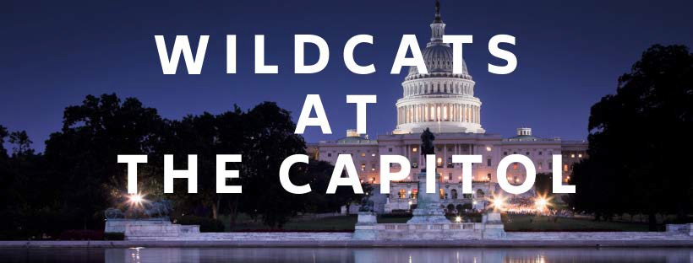

Spend a semester interning in Washington, D.C. with your fellow Wildcats. WilDCats at the Capitol is the University of Kentucky's federal government internship program that offers any UK student the opportunity to intern, earn course credit, and gain experience at the highest levels of government while living in the nation's capital.

# Return this application, resume, letter of recommendation and transcript to [wildcatsintern@uky.edu](mailto:wildcatsintern@uky.edu).

**\*Letters of Recommendation should be sent directly to** [**wildcatsintern@uky.edu**](mailto:wildcatsintern@uky.edu) **with letters arriving on application due date or soon thereafter\***

**Applicant Information**

Student ID Number: ___________________________

Date of Application:___________________________

Full name: ___________________________________

Date of Birth: ________________________________

Home address: _______________________________

City, State, Zip: ______________________________

Cell: _______________________________________

Email: ______________________________________

Semester Applying For: ________________________

How did you hear about the program? (highlight all that apply)

Online Recruitment Session Friend In class Program Flyer

College Internship Director Other (specify)

|  |  |
| --- | --- |
| Classification as of Application Date: | Cumulative Grade Point Average: |
| Major(s):  Minor(s):  Fields of Study:  Other: | |

|  |
| --- |
| Do you live in the district of a member of Kentucky’s congressional delegation? If so, which district? |
| If applicable, please provide a brief explanation of why you would like to work for this individual. (100 words or less) |

If you prefer to work with specific members of Congress, please list their names here:

Do you have a preferred party affiliation for your internship? If so, list it here:

What type of internship(s) are you looking for?

1. Discuss what prompted you to apply the DC program, how the program fits with your academic and career goals, and how your past experiences and academic work have prepared you for Washington (500 words or less)
2. Please list three policy/legislative issues that interest you. In your answer, please also discuss why each is of interest to you.

Open-Ended Questions *(Please respond on a separate document)*